**Redes:**

Rede externa na esquerda – 193.136.212.128/26

R1 – 193.136.212.190/26

PC1 – 193.136.212.129/26

PC2 – 193.136.212.130/26

Rede externa na direita – 193.136.212.192/27

R2 – 193.136.212.222/27

PC3 – 193.136.212.193/27

PC4 – 193.136.212.194/27

Rede externa no meio – 193.136.212.224/29

R1 – 193.136.212.225/29

R2 – 193.136.212.226/29

R3 – 193.136.212.227/29

Rede do servidor – 10.90.0.0/24

R3 – 10.90.0.254/24

Server – 10.90.0.1/24

**Comandos usados na configuração dos dispositivos:**

R1:

conf t

interface e0/0

ip address 193.136.212.190 255.255.255.192

no shut

exit

interface f1/0

ip address 193.136.212.225 255.255.255.248

no shut

exit

ip route 193.136.212.192 255.255.255.224 193.136.212.226 – rota estática para rede externa direita

exit

R2:

conf t

interface e0/0

ip address 193.136.212.222 255.255.255.224

no shut

exit

interface f1/0

ip address 193.136.212.226 255.255.255.248

no shut

exit

ip route 193.136.212.128 255.255.255.192 193.136.212.225 – rota estática para rede externa esquerda

exit

R3:

conf t

interface e0/0

ip address 10.90.0.254 255.255.255.0

ip nat inside

no shut

exit

interface f1/0

ip address 193.136.212.227 255.255.255.248

ip nat outside

no shut

exit

ip route 193.136.212.128 255.255.255.192 193.136.212.225 – rota estática para rede externa esquerda

ip route 193.136.212.192 255.255.255.224 193.136.212.226 – rota estática para rede externa direita

access-list 1 permit 10.90.0.0 0.0.0.255 – criação de lista para SNAT com rede do server

ip nat inside source list 1 interface f1/0 overload – criação da tabela SNAT com recurso a overload

ip nat inside source static tcp 10.90.0.1 80 193.136.212.227 80 – configuração DNAT para server

exit

PC1: ip 193.136.212.129/26 193.136.212.190

PC2: ip 193.136.212.130/26 193.136.212.190

PC3: ip 193.136.212.193/27 193.136.212.222

PC4: ip 193.136.212.194/27 193.136.212.222

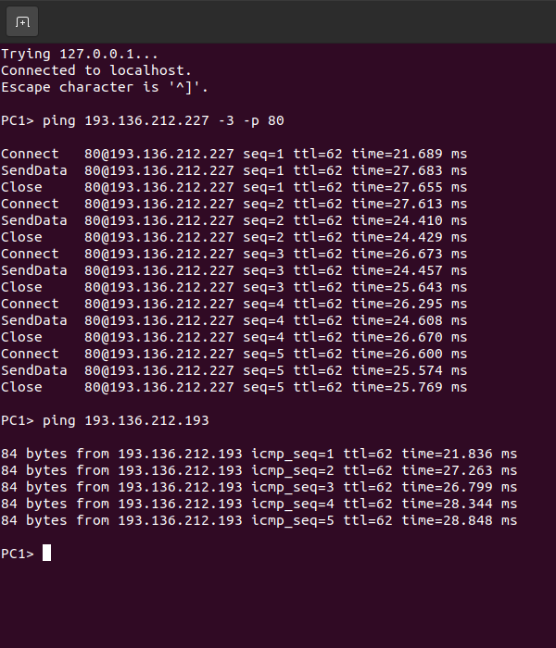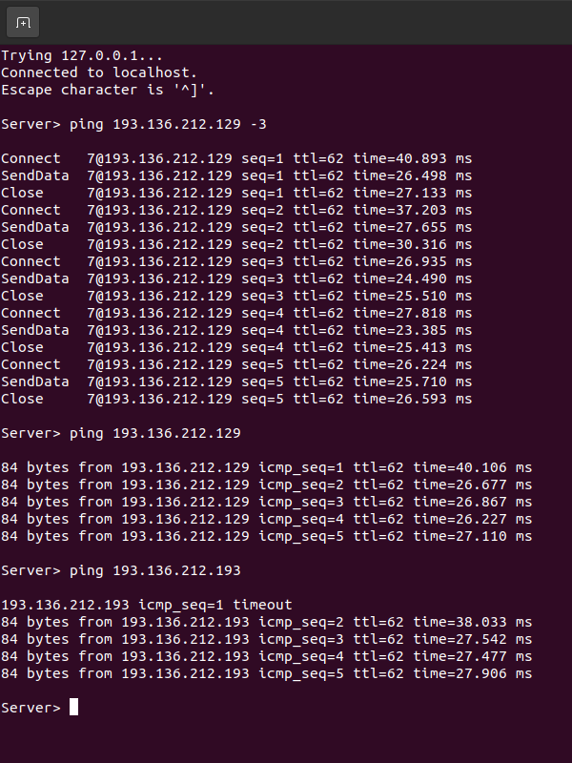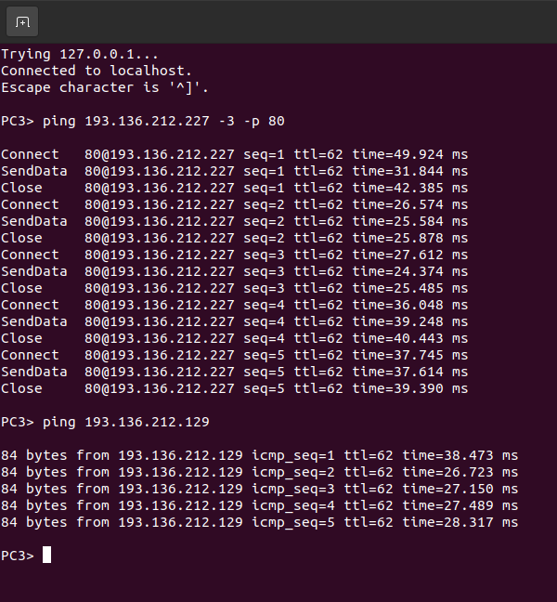

Ping da rede direita para as outras

Ping da rede esquerda para as outras

Ping da rede do meio para as outras

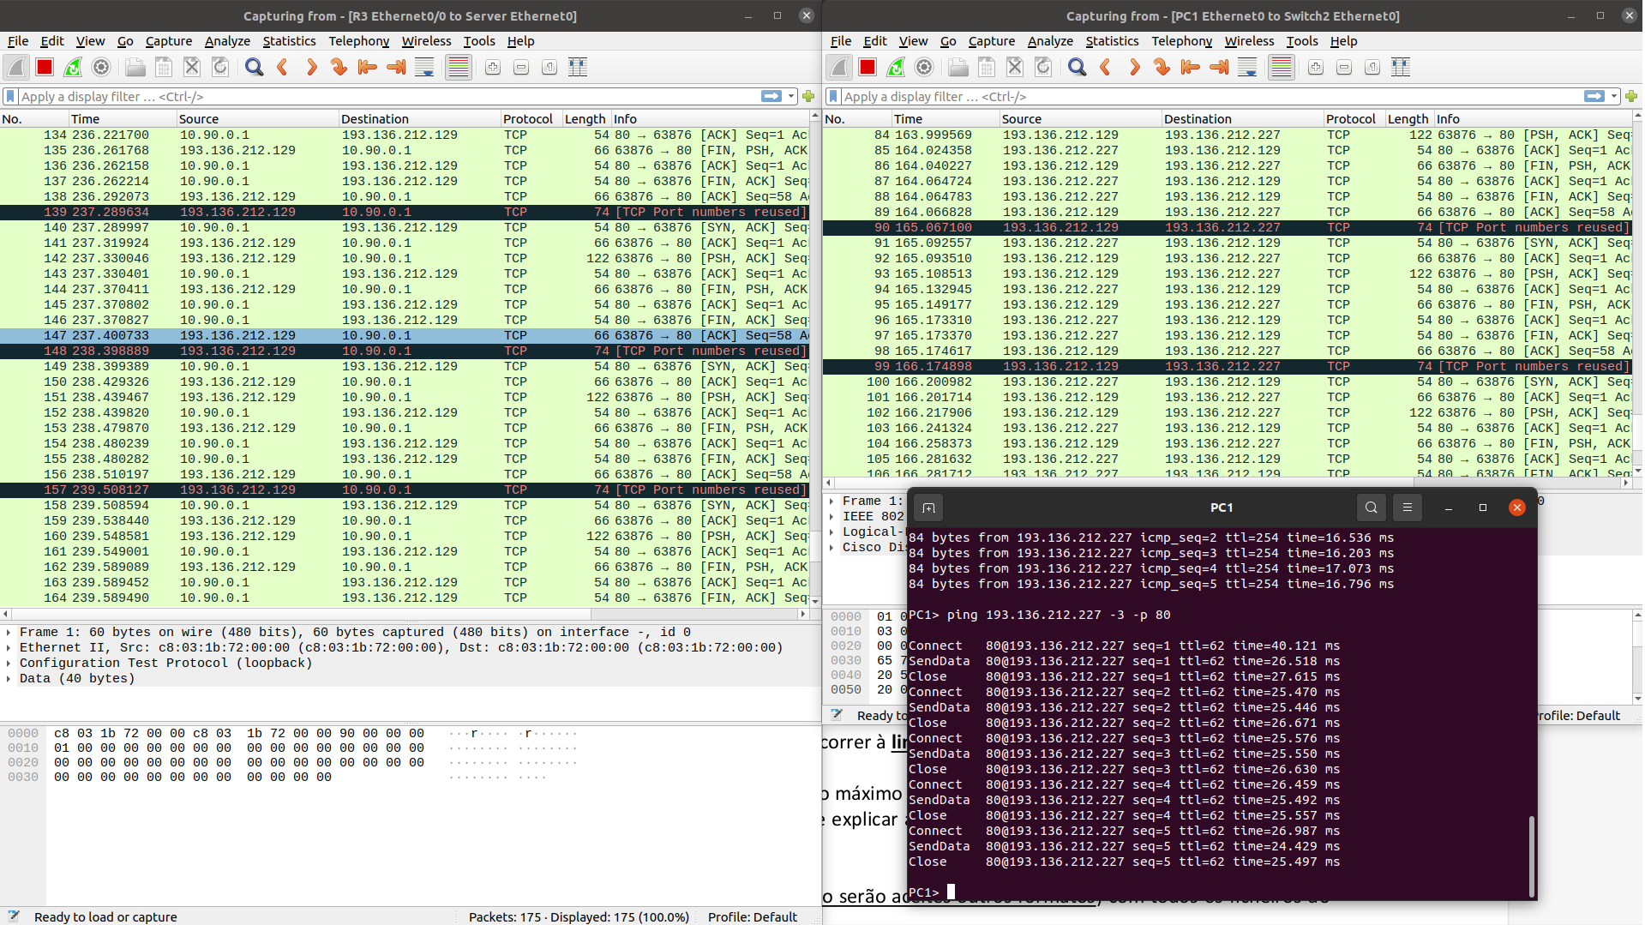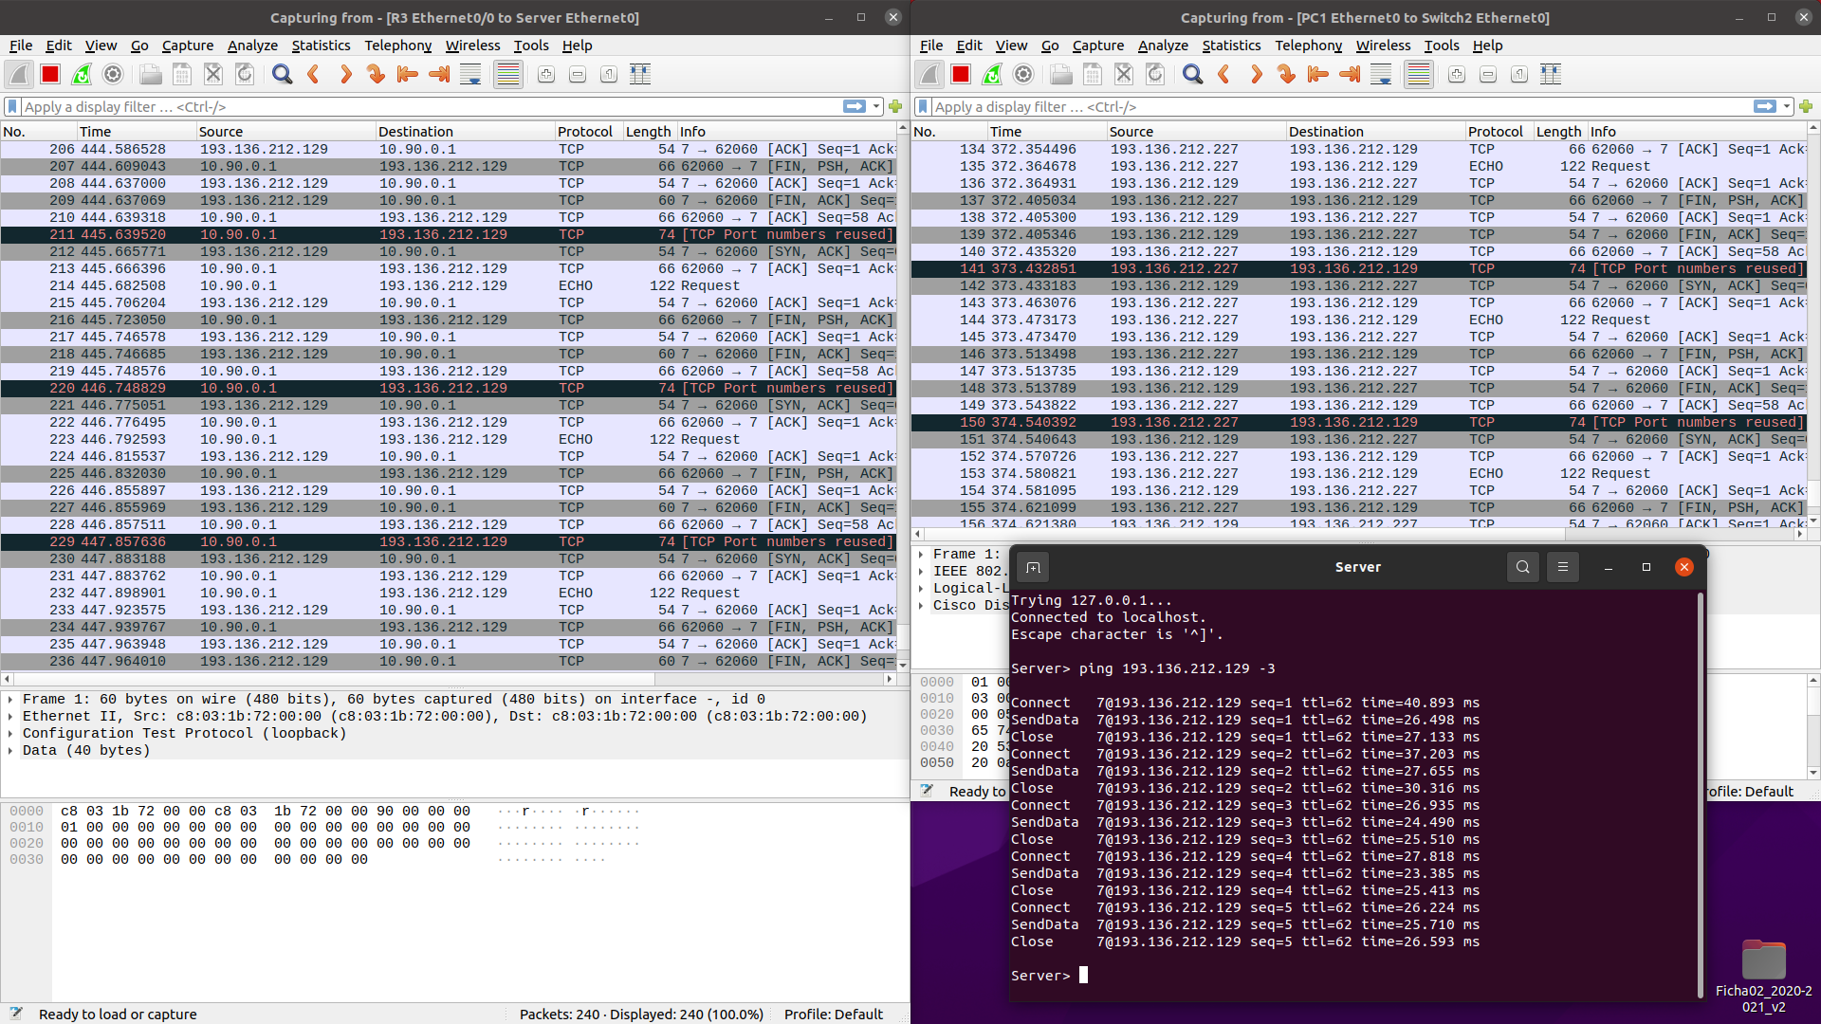

Teste DNAT

Teste SNAT